Shiny Server is a free and open-source option for self hosting Shiny apps and it is one of the 3 options listed on the Shiny website. Follow the instructions from the previous post or spin up a brand new virtual machine on DigitalOcean using the RStudio 1-click app in minutes.

The index.html file for the Shiny Server's landing page and the hello and rmd apps are in the /srv/shiny-server/ folder:

$ ls /srv/shiny-server/ index.html sample-apps

$ ls /srv/shiny-server/sample-apps/hello server.R ui.R

$ ls /srv/shiny-server/sample-apps/rmd index.Rmd

These directories map to the server path as:

http://$HOST is the landing page (index.html), http://$HOST/sample-apps/hello/ is the hello app, http://$HOST/sample-apps/rmd/ is the rmd app.

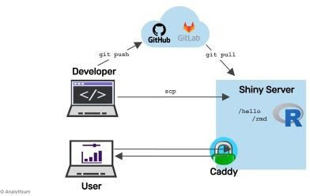$HOST is the custom domain (e.g. yourdomain.com ) your Shiny Server server is using. You can see that the folder structure inside /srv/shiny-server/ directly translates to the server paths. How do you add more apps to the server? Just copy the Shiny apps directly into folders within the /srv/shiny-server/ directory. Here are three options for doing it.

File based deployment of Shiny apps to Shiny Server

# Edit text files on the server

Let's add an app called histogram to the http://$HOST/histogram/ path:

mkdir /srv/shiny-server/histogram cd /srv/shiny-server/histogram touch app.R

nano app.R

Copy-paste the Shiny app from below into app.R that you just opened with nano (Ctrl+O to save, Ctrl+X to exit nano): library(shiny)

ui = fluidPage( mainPanel(

sliderInput("obs",

"Number of observations", min = 1,

max = 5000,

value = 100), plotOutput("distPlot")

)

)

server = function(input, output) { output$distPlot = renderPlot({

dist = rnorm(input$obs) hist(dist,

col="purple", xlab="Random values")

})

}

shinyApp(ui = ui, server = server)

Now if you visit http://$HOST/histogram/ you'll see a range slider controlling sample size and a purple coloured histogram of a Normal distribution that must be familiar from a previous post.

## Secure copy the files

You can use scp to copy local files to the server. Let's create a small Shiny app on your local machine. Use the same code as for the purple histogram, but change some of the settings:

mkdir pink

touch pink/app.R nano pink/app.R

Copy this code into the file pink/app.R:

library(shiny) ui = fluidPage(

mainPanel(

sliderInput("obs",

"Number of observations", min = 1,

max = 1000,

value = 100), plotOutput("distPlot")

)

)

server = function(input, output) { output$distPlot = renderPlot({

dist = runif(input$obs) hist(dist,

col="pink", xlab="Random values")

})

}

shinyApp(ui = ui, server = server)

The following script copies the local pink directory over to the pinkhist directory of the Shiny Server (this use of scp assumes you access the server using your ssh key pair, otherwise you'll be prompted to provide your username/password):

export APPDIR="pink" export SHINYDIR="pinkhist"

scp -r $APPDIR root@$HOST:/srv/shiny-server/$SHINYDIR

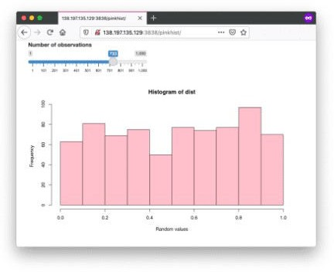Visiting the http://$HOST/pinkhist/ address should reveal the new app:

Note that the scp protocol uses port 22 similarly to ssh and sftp. If you are using the non-secure FTP protocol to copy the files, make sure port 21 of your server is open for incoming traffic.

## Git based deployment

Set up git so you can work with your public and private repositories (git is already installed, this is a one-time setup for each user):

git config --global user.email "[you@example.com](mailto:you@example.com)" git config --global user.name "Your Name"

Change to your home directory with cd ~ and run the following script. This will clone the GitHub repository specified in the environment variables, or pull changes if the directory already exists; then makes a directory for Shiny Server if that directory is not already there, then copies the app files ($APPDIR can be empty):

#!/bin/bash

export GITHOST="https://github.com" export GITUSER="analythium" export GITREPO="covidapp-shiny" export APPDIR="02-shiny-app/app" export SHINYDIR="covidapp"

# clone or pull repo

if [[ ! -e $GITREPO ]]; then

git clone $GITHOST/$GITUSER/$GITREPO.git else

cd $GITREPO git pull cd ..

fi

# make dir if not already there mkdir -p /srv/shiny-server/$SHINYDIR

# copy repo contents to Shiny Server

cp -rf $GITREPO/$APPDIR/* /srv/shiny-server/$SHINYDIR

You can modify this script for other repositories and save in a file, e.g. update_covid.sh . Then you can run bash update_covid.sh every time you need the app to be updated. It is also possible to set up a cron job to update the app daily or tie the script to a webhook event triggered by a successful GitHub action.

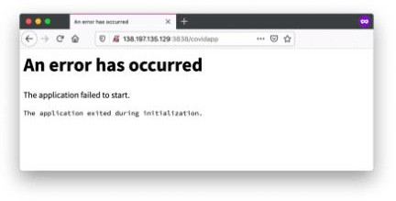But before you do any of that, check if the app is running fine at http://$HOST/covidapp/. If all went wrong, you should see this message:

This happened because the Shiny Server setup only included the most basic R packages and we missed the forecast package required by the COVID-19 app. Let's remedy this:

R -q -e "install.packages('forecast')"

If you refresh the page now the app should work fine.

This immediately highlights one of the shortcomings of Shiny Server when it comes to continuous integration and delivery (CICD). You need to be extra careful when managing packages, R and package versions, etc. when you have multiple apps with possibly conflicting dependencies. Dockerizing Shiny apps is one solution to isolate your applications.

